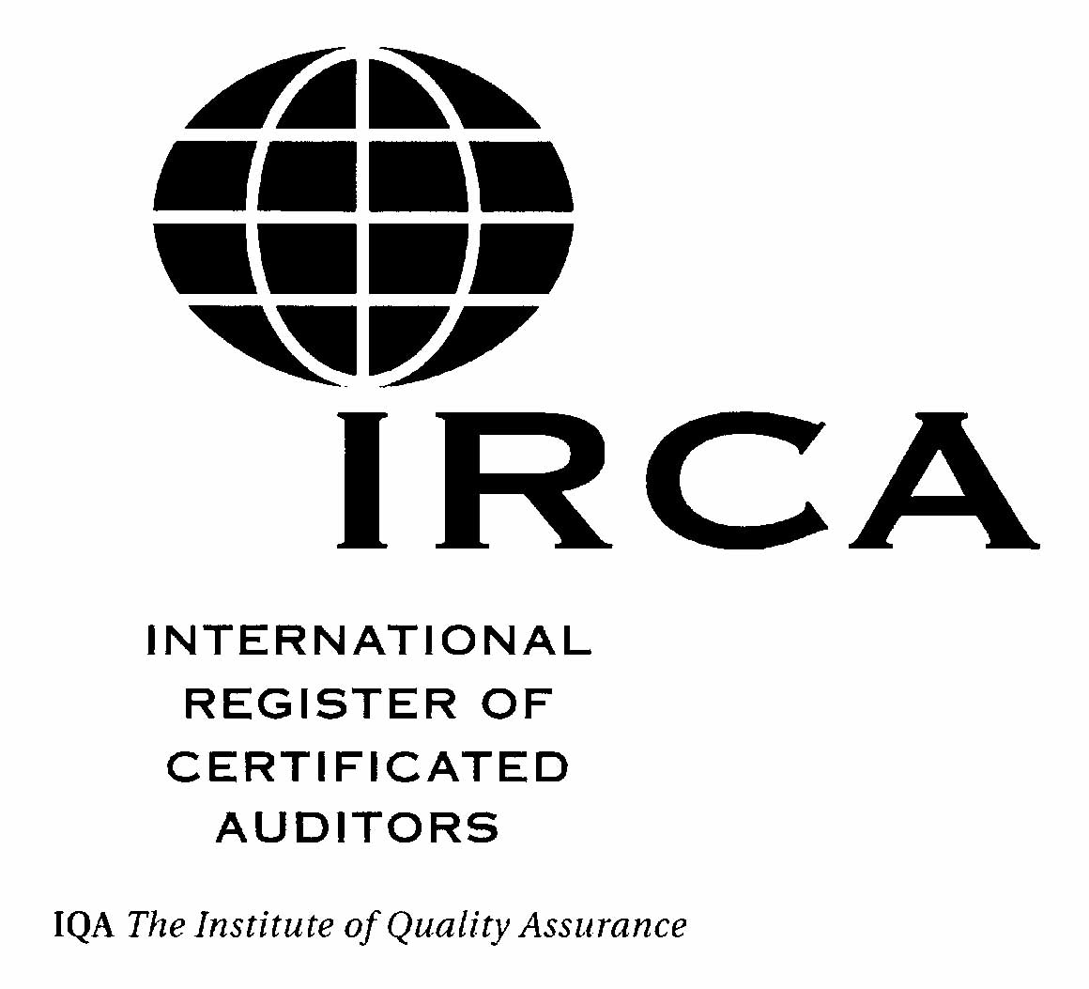
AUDIT LOG

FORM: IRCA/106/04/1
CONFIDENTIAL WHEN COMPLETE
See over for guidance. Photocopies of this document may be used
Name & Initials…………………………………………………………..……….

Sheet………………………. | Of…………Certification No……………………… |  |  | .
PLEASE USE BLOCK LETTERS (where Applicable)

- Date  (DD/MM/YY) | 2. Duration of Audit in days |  | - Audited company name  - Complete address  - Auditee contact name  - Telephone/Fax number  - E-mail address  - Size of organisation  (e.g. number of people employed) | 4. Role in Audit  - Auditor  - Lead Auditor  - Sole Auditor  - Internal Auditor | 5. Total number  in team | 6.Audit Standard  (e.g. ISO 9001: 2000) | 7. Type of Audit  (Important see reverse) | 8. Contact details of the company that employed you:  - Company name  - Complete address  - Contact name  - Signature  - Position within organisation  - Contact Telephone/Fax number  - Email address | 9. Contact details of the Directing & Guiding Lead Auditor:  - Name  - Signature  - Auditor Certification number  - Contact Telephone/Fax number  - E-mail address
- Date  (DD/MM/YY) | On-site Time | Off-site Time

Column 1 | Date: Day, month and year of the first day of the site visit, beginning with the opening meeting. | GENERAL GUIDANCE ON ACCEPTANCE OF AUDITS:  What audits do we accept? For all grades except Lead Auditor at initial certification, we will only accept audits performed during the previous 3 year period. For Lead Auditor grade, you must have acquired the lead audit experience during the previous 2 years. We define ‘previous period’ as being that period immediately prior to the date we receive your completed application.  We must be able to verify all audit experience you submit in your log sheets. Please make sure you include detailed information of the audits you perform and provide sufficient contact details so that we able to perform the verification.  We will only accept audits that have been performed in accordance with the auditing guidance standard, ISO 19011:2002 (or ISO 10011, for audits conducted prior to the issue of ISO 19011) and against the standard defined in the corresponding requirements / criteria documents (e.g. for the IRCA/602 QMS 2000 scheme we require audits against ISO 9001:2000 or an alternative standard we accept as being equivalent). Audits performed against alternative national, international or company standards may be acceptable.  We will accept supplier audits (also known as second party audits), and certification audits (also known as third party audits) and internal audits (also known as first party audits). We also accept consultancy audits (see below), which can be performed as first, second or third party audits.  Internal (first party) audits: For the Internal Auditor grade we will accept internal audits performed by you on parts of your own organization where you are independent from the operational activities you are auditing.  We will consider accepting internal audits for other grades providing that, in addition to you being independent from the operational activities you are auditing, the scope of the auditing was sufficiently broad and the audit was sufficiently complex to require you to use a range of auditing skills. So that we can consider your internal audits for acceptance, we advise you to provide us with appropriate and relevant supporting information.  Consultancy Audits: We will accept audits performed by you when acting as a consultant for a client if all the following are satisfied:  - The client (auditee) already had a fully established management system prior to the audit  - You had no part in setting up the management system being audited (except in specific circumstances as described below)  - You were independent of the auditee  - The scope of the audit included all elements of the management system | We will also accept pre-assessment audits performed by you on a management system that you were involved in developing if the certification body subsequently awarded certification at the first attempt.  Surveillance (partial system) audits: We do not normally accept surveillance (partial system) audits when submitted for initial certification (except for Internal Auditor grade). However, we do accept surveillance audits for renewal of certification. As a general rule we consider five surveillance audits to be equivalent to one full management system audit, but recognize that some surveillance audits can be very extensive. In such instances, we will accept fewer than five surveillance audits (as being equal to one full management system audit) if you provide us with evidence that supports your claim.  Audits we do not accept:  We do not accept:  - audits of the same management system that are repeated more frequently than once every 12 months.  - audits of less than one day (6 hours of on-site audit activity exclusive of breaks) duration, except for Internal Auditor grade where we will accept audits of 3 hours exclusive of breaks.  - gap analysis, close out or follow up visits.  - audits performed before successful completion of the formal training requirement.  THESE GUIDANCE NOTES SHOULD BE READ IN CONJUNCTION WITH THE APPLICABLE AUDITOR CERTIFICATION CRITERIA (available at www.irca.org)  IRCA/602 - ‘Certification as a Quality Management Systems  (QMS 2000) Auditor’  IRCA/102 - ‘Certification as a Quality Management Systems  (QMS) Auditor’  IRCA/202 - ‘Certification as an Environmental Management Systems  (EMS) Auditor’  IRCA/502 – ‘Certification as an Occupational Health & Safety Management  Systems (OH&S) Auditor’  IRCA/162 - ‘Becoming a TickIT Auditor Requirements  for IRCA certification’  IRCA/C5 - ‘Criteria for Certification as a QMS +  Aerospace Auditor’  IRCA/C8 - ‘Criteria for Certification as a Maritime  (ISM Code) Auditor’  IRCA/802 - ‘Certification as an Information Security  Management Systems (ISMS) Auditor’  IRCA/902 - ‘Certification as a Food Safety Management  Systems Professional’
Column 2 | Duration: Total time of the audit in days (to the nearest half day).  On site Time: Time spent on actual auditing activities, from the opening to the closing meeting inclusive.  Off-site Time: Time spent on planning/preparation, document review and report writing.  These activities may take place at the site of the audit or off location, but is still considered off-site time.
Column 3 | Auditee Contact Details: This section must be completed in full for us to perform evaluation and verification. If any of this information is not available we may ask you to supply us with more evidence.
Column 4 | Role in Audit: Please indicate Auditor, Lead Auditor, Sole Auditor or Internal Auditor as appropriate.  Only enter Lead Auditor if you led a team consisting of yourself and at least one other auditor.  Please enter Sole Auditor if you carried out an audit where you were the only auditor and performed all phases of the audit.
Column 5 | Total number in team: Number of active participating auditors, including yourself, on the audit team.
Column 6 | Audit standard: If your audit standard is not referenced in the corresponding auditor certification criteria or on the equivalent standards list (all available at www.irca.org) please contact the IRCA secretariat for advice and/or submit to IRCA, with your audit logs, a copy of the standard for evaluation.
Column 7 | Audit type: Third Party (TPA), Second Party (SPA), First Party /Internal (FPA), Consultancy or contracted (CON). For audit events classified as (TPA) further explanation of purpose should be included. i.e. pre-assessment, certification, surveillance (Surv.), re-assessment, stage 1, stage 2 etc
Column 8 | Contact Details of the company that employed you: the company that employed you for the audit, i.e. your employer or client if consultancy/contracted audit.  This section must be completed in full for us to perform evaluation and verification. If any of this information is not available we may ask you to supply us with more evidence
Column 9 | Contact Details of the Directing & Guiding Lead Auditor: The contact details and status of the team leader under whose direction and guidance¹ you completed the recorded audit(s).  This lead auditor must be competent².  This section must be completed in full for initial applicants for certification and certified auditors that are regrading. If any of this information is not available we may ask you to supply us with more evidence. Certified auditors renewing certification at the same grade do not need to complete this section.  1.Direction and guidance does not mean that you must be under constant supervision nor does it mean someone needs to be assigned solely to perform this task.  2. Currently certified as a lead auditor by IRCA (or another recognised auditor certification body) or who has the equivalent competence.  Competence is defined by having the Personal Attributes described in sub clause 7.2 of ISO 19011:2002, the ability to apply the knowledge and skills described in sub clause 7.3, gained through the education, work experience, auditor training and audit experience described in sub clause 7.4

